East/West Norriton Fire Companies Golf Outing

GOLFER FORM 2024

Contact Name: _______________________________________________

Address:______________________________________________________

Phone Number:________________________________________________

Email Address: _______________________________________________

Check Number:_________________ Amount: $________________

Make Checks payable to: Jefferson Fire Co No1.

Golfer#1:_____________________________ Shirt Size: L, XL, 2X, 3X

Golfer#2:_____________________________ Shirt Size: L, XL, 2X, 3X

Golfer#3:_____________________________ Shirt Size: L, XL, 2X, 3X

Golfer#4:_____________________________ Shirt Size: L, XL, 2X, 3X

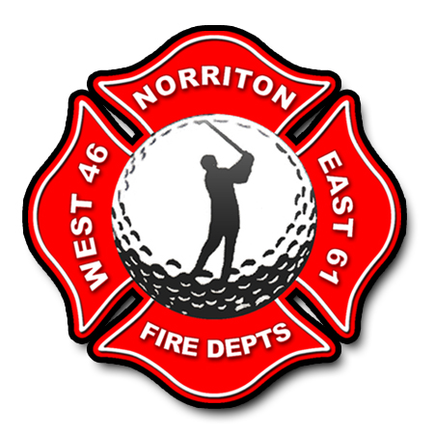

Any Questions Call (610) 539-3990 Jefferson Fire Co No. 1
85 School Lane, Norristown, Pa 19403

